ARCHITECT REVIEW
SCC-3385 | Create Work Order for Tickets
Great Plains Merge to UAT | Source retrieval and check-only readiness assessment
Source | GreatPlainsMerge | Org 00DEa00000GkAsHMAV
Target | GreatPlainsUAT | Org 00DEa00000FZlLBMA1
Review date | 26 August 2026
Check-only | Failed | Job 0AfEa00000bbQXhKAM | 6/14 validated
Decision | NO-GO - Changes Requested before promotion
Boundary | No records, deployment, activation, or org metadata were changed

ARCHITECT DECISION
Do not promote SCC-3385. UAT lacks the Trouble Ticket foundation, the source Order exception is incomplete, WorkOrder layouts omit the new fields, and the check-only package failed 8 of 14 components.

Acceptance outcome
# | Scope | Result | Evidence
1 | Action visibility | Partial fail | Source layout contains Create Work Order; UAT has no Trouble Ticket record type, so visibility cannot validate.
2 | Inherited details | Partial fail | Flow maps Account, address, service, report, notes, and priority; target dependencies and WorkOrder layout fields are missing.
3 | Required inputs | Static pass | Flow requires Work Type and Work Instructions. UAT has all four named trouble Work Types.
4 | Duplicate prevention | Static pass | Flow checks CaseId and links the existing Work Order; Source_Case_Id__c is unique. Runtime is untested.
5 | Case activity logging | Static pass | Flow creates a completed Task with Work Order number and Work Type. Runtime is untested.
6 | Book Appointment | Static pass | FSL__Book_Appointment remains on the FSL layout; no runtime regression was executed.

Deployment readiness path
The source implementation is visible, but the promotion path breaks on prerequisite metadata, broad profile drift, and unresolved source design defects.
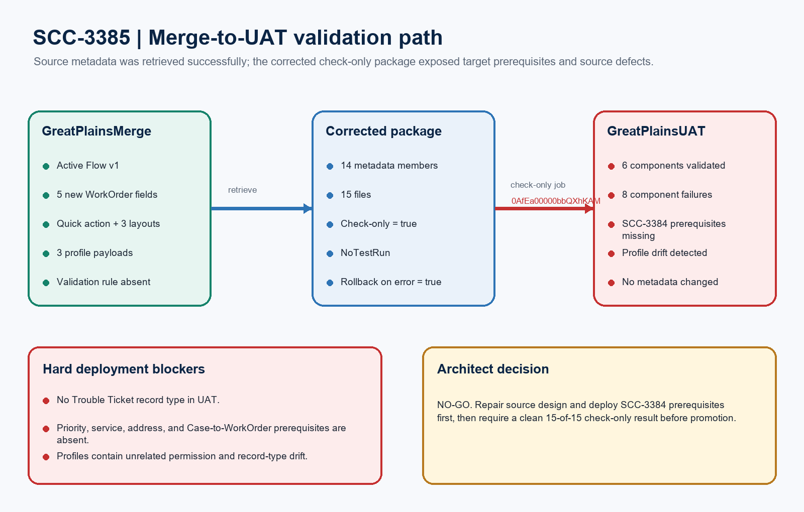
Figure 1. SCC-3385 Merge-to-UAT validation path
DESIGN READING
Green/blue is present in source. Amber requires repair. Red blocks promotion.

Detailed dry-run findings

1. Check-only deployment evidence
Metric | Result | Evidence
Job | 0AfEa00000bbQXhKAM | checkOnly=true; rollbackOnError=true; NoTestRun
Payload | 14 components / 15 files | 1 Flow, 1 Quick Action, 6 fields, 3 layouts, 3 profiles
Validated | 6 | All six WorkOrder field members validated; five are new and Order__c is changed.
Failed | 8 | Flow, Quick Action, three layouts, and three profiles failed.
Tests | 0 | No Apex in scope; functional story tests require controlled record writes.

2. Exact failure groups
Failure group | Affected | Exact blocker
Missing Case prerequisites | 4 components | Service Address, Priority__c, Case-to-WorkOrder relationship, and Trouble Ticket record type are absent in UAT.
Profile drift | 3 profiles | Admin and API profile use unknown ArchiveArticles; Standard references the missing Trouble Ticket record type.
Quick Action cross-reference | 1 action | Case.Create_Work_Order cannot resolve its Flow because the referenced Flow fails validation.

3. Source and story defects
Area | Status | Evidence
Order exception | Blocker | Order__c remains required=true; WorkOrder.Order_Required_Except_Trouble_Ticket does not exist.
WorkOrder layouts | Changes requested | Neither updated WorkOrder layout includes the five new SCC-3385 fields.
Component names | Correct story | Actual action is Case.Create_Work_Order; profile API names are Admin, Standard, and System Administrator - API Only.
Named Cases | Blocked | Cases 00001082 and 00001083 exist in neither authorized Great Plains sandbox.
Work Types | Ready in UAT | Comm Fiber, Resi Coax, Resi Copper, and Resi Fiber Trouble all exist in UAT.

Work Order creation architecture
The Flow contains most behavioral controls, but the target foundation and two source-side design elements prevent a complete end-to-end release.
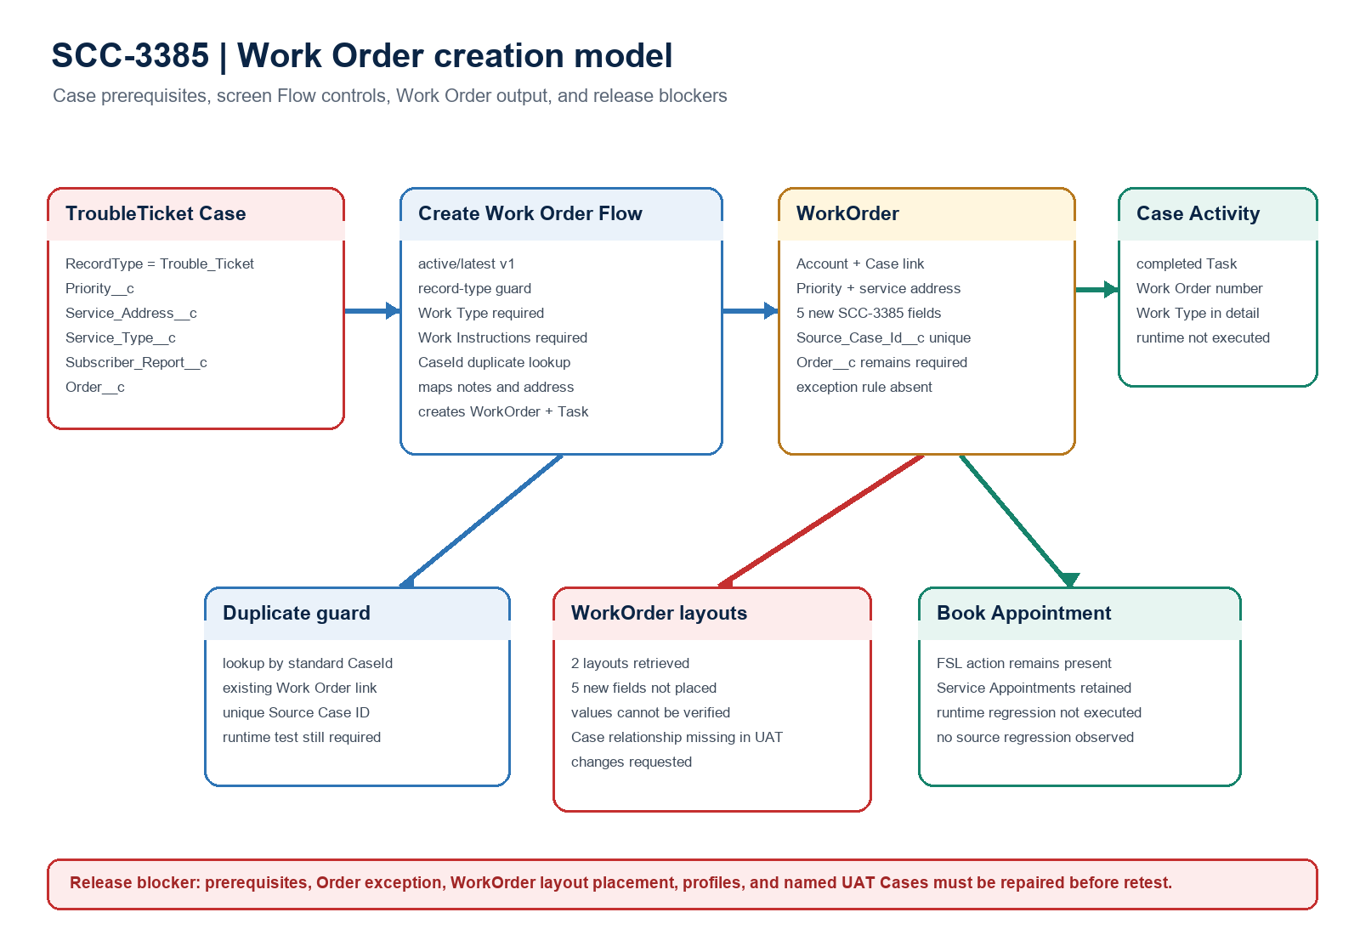
Figure 2. SCC-3385 Work Order creation and dependency model
Architect interpretation: the Flow design covers gating, required inputs, duplicate detection, value mapping, and activity logging, but deployment and runtime acceptance remain blocked until the foundation and source defects are repaired.

Required approval gates
Gate | Required action | Owner | Evidence needed
1 | Deploy SCC-3384 prerequisites | Release manager | Trouble Ticket record type plus Priority, Service Address, Service Type, Subscriber Report, and Work Order Case fields.
2 | Repair the Order exception | Admin / Architect | Make Order__c optional and add the active exception validation rule for non-Trouble Ticket Work Orders.
3 | Complete WorkOrder layouts | Salesforce admin | Place all five new fields on both WorkOrder layouts and retain Book Appointment.
4 | Narrow security payload | Security owner | Use a focused permission set or filtered profiles; remove ArchiveArticles and unrelated record-type drift.
5 | Prepare named UAT Cases | QA / Business | Create or identify Cases 00001082/00001083 equivalents with exact Account, address, service, report, priority, and notes.
6 | Revalidate and execute UAT | QA / Release manager | Require a clean 15/15 check-only result, then execute all six tests with IDs and screenshots.

Ready-to-paste architect response
STORY COMMENT
Architect dry run completed for SCC-3385 using GreatPlainsMerge as source and GreatPlainsUAT as the check-only target. Changes Requested / NO-GO: job 0AfEa00000bbQXhKAM was check-only and failed with 8 of 14 components; no metadata or records were changed. UAT is missing the Trouble Ticket record type and the SCC-3384 Case fields used by the Flow. In source, WorkOrder.Order__c remains required, the listed exception validation rule does not exist, and neither WorkOrder layout contains the five new fields. The Flow otherwise includes the record-type guard, required Work Type and Work Instructions, duplicate lookup/link, Case value mapping, completed Task logging, and the FSL Book Appointment action remains present. Complete the six approval gates above, prepare valid test Cases, and require a clean 15-of-15 validation plus all six UAT tests before promotion.

Evidence boundary
This assessment combines source metadata retrieval, local structural review, read-only org queries, and a GreatPlainsUAT check-only deployment. No records, deployment, activation, quick deploy, or org metadata changes were performed.

